FURSYS-KOREA

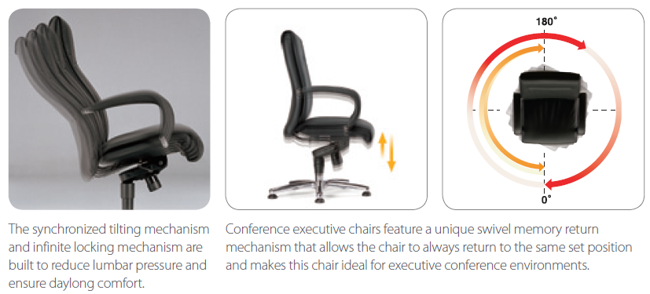

The PRONARD chairs are elite with refined elegance, putting the PRONARD series in a class by itself. The soft natural leather, impeccable seams, synchronized tilt and polished five-star base are truly impressive to behold, while the seat comfort is unrivaled.

